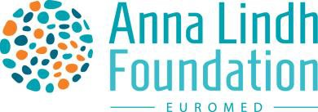

MEDITERRANEAN CAPITALS OF CULTURE & DIALOGUE

2nd Edition - 2026

Annex IV

Calendar

|  |  |  |
| --- | --- | --- |
| **Action** | **Description** | **Deadline** |
| **Launch of the call for applications 2026** | Opening of the call | 7 February 2024 |
| Online info-sessions | February 29, March 28, April 26, May 24, June 27 / 2024 |
| **Closure of the call for applications 2026** | Deadline for applications | 7 July 2024 |
| **Evaluation of the applications** | Assessment by the Advisory Committee and consultation of the recommendations with the UfM Co-Presidency | October 2024 |
| Submission to the UfM Senior Officials and deliberations | November 2024 |
| **Announcement** | Announcement of the two Mediterranean Capitals of Culture 2025 | 28 November 2024/9th UfM Regional Forum |
| ***Preparation of the Mediterranean Capitals of Culture 2026*** | *Meetings with the two selected cities* | *January 2025*  *May/June 2025*  *October/November 2025* |